**Security Testing**

Objective: To ensure the system is protected from possible intruders and finding all possible loopholes.

Tool Used: Immuni Web

The security testing was done on the following parameters:

* Tested on: Dec 1st, 2024 04:58:38 GMT +5:30
* Server IP: 76.76.21.61
* Reverse DNS: Absent
* Location: Walnut, USA
* Client: Desktop version

**Server Security Test**

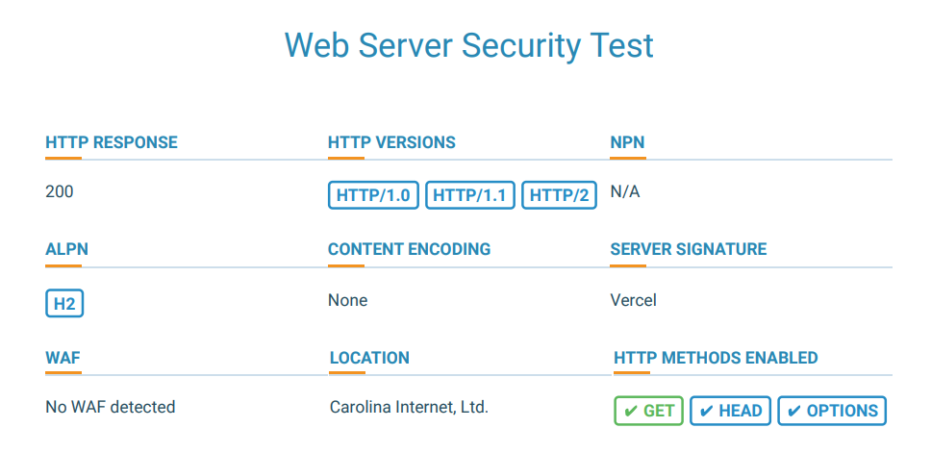

**Software Security Test**

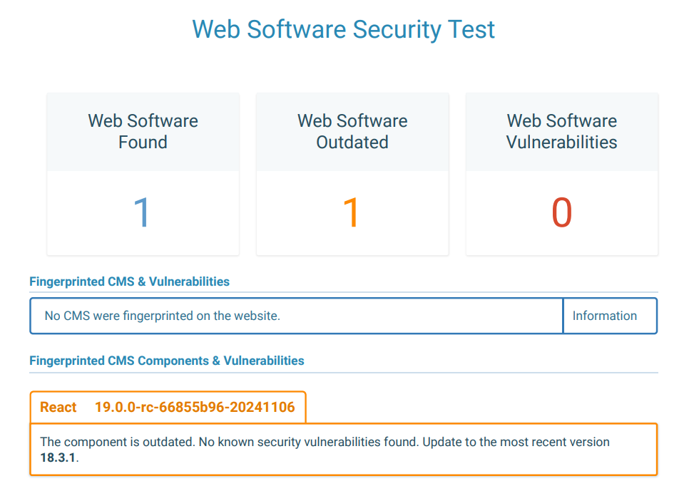

**GDPR Compliance Test**

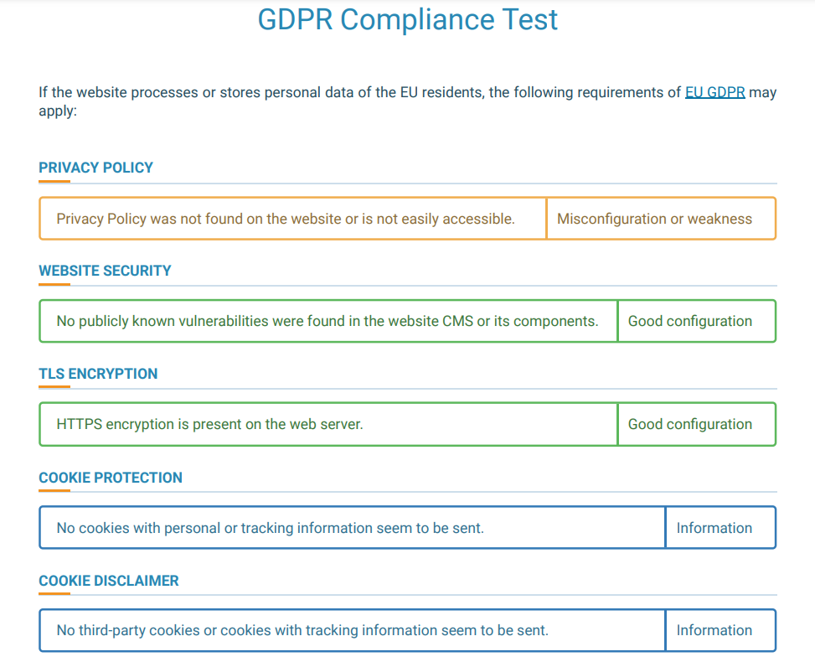

**HTTPS Headers Security**

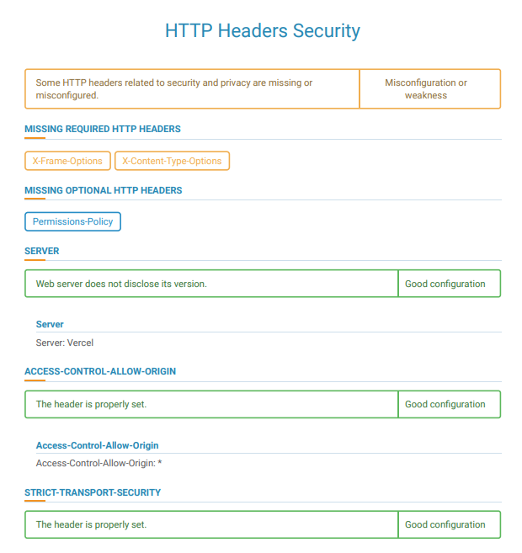

**Cookie Privacy**

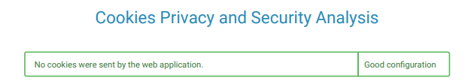

Summary:

* GET HTTP method is enabled
* No CMS is present
* Software Component is outdated in website
* No privacy policy found
* No publicly found vulnerabilities
* HTTPs encryption present
* No cookies
* No third-party cookies
* Header properly set
* Web server does not disclose the its version